M.S. Ramaiah College of Arts, Science & Commerce 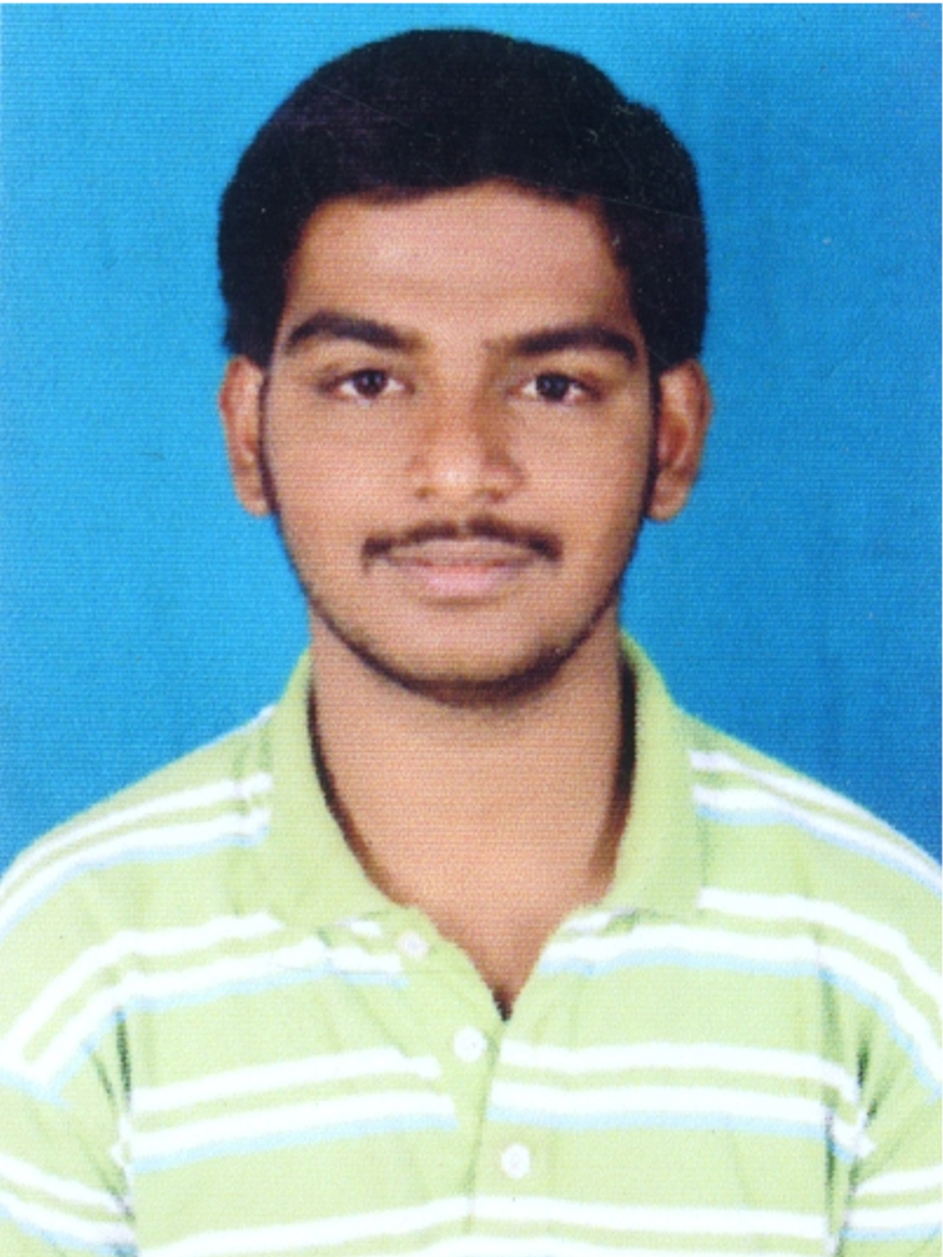
(Affiliated BU)
The Department Of Placement & Training
M.S. R Nagar, MSRIT Post, Bangalore – 560 054.
Phone: (080) 23601748
Email: placements.msrcasc@gmail.com And Website : www.msrmsc.org

Curriculum Vitae - (U.G.)

Name in full: Mr./Ms. Shashank Sukumar Mucheli |  |  |  |  |  | Date of birth: 20/07/1991
Father’s name: Sukumar M R
Name of the U.G. Course: Bachelor Of Computer Applications
Education:
Course |  | Institution studied |  |  |  | % Marks | Year of passing
S.S.L.C |  | Sri Vidya Mandir Education Society, Malleshwaram, Bangalore-03 |  |  |  | 67 | 2007
II PUC/ Diploma |  | Sheshadripuram Composite Pre-University College,Sheshadripuram |  |  |  | 56 | 2009
Graduation: Graduating year and month -

Semester | % Marks |  | Year of Passing |  | Semester | % Marks |  | Year of Passing
I | 64.2 |  | 2009 |  | V
II | 65.4 |  | 2010 |  | VI
III | 60 |  | 2010 |  | VII
IV | 58.4 |  | 2011 |  | VIII

% Marks (Up to IV semester) = 62

Computer knowledge/ Projects/ Any other co-curricular & extra curricular activities
- C
- C++
- Shell scripting
- Visual Basic 6.0
- SQl using SQL plus
- Java(Learning)
Projects:
- Designed a Software to Bill and Manage Stocks in the warehouse for the Wholesale Shops.
Extra Curricular Activities :
- Helped the Dept of Languages in making presentations and scripts during the NAAC visit in the year 2009

Address for communication:  Shashank M S, s/o Sukumar M R, D.no:15, 15th ‘B’ Cross, 8th Main Road, Bandappa Garden, Mutyalanagar, Bangalore-560054  Phone: +91 9916533538, +91 9341260602, +91 80 23478981 | Permanent address:  Shashank M S, s/o Sukumar M R, D.no:15, 15th ‘B’ Cross, 8th Main Road, Bandappa Garden, Mutyalanagar, Bangalore-560054  Phone: +91 9916533538, +91 9341260602, +91 80 23478981
E-mail ID: shashank.venku@gmail.com
I declare that the information given above is true to the best of my knowledge
Date:30/08/2011

Place: Bangalore Signature of the Candidate:

